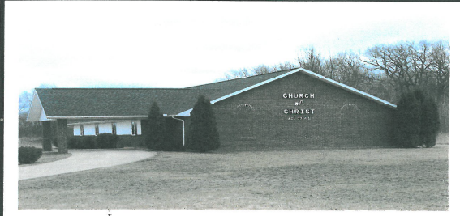
(B) = Birthday
(A) = Anniversary
Sunday | Monday | Tuesday | Wednesday | Thursday | Friday | Saturday
 |  |  |  |  |  | 1
2  Bible Study  10:15 a.m. – 10:50 a.m.  Worship 11 a.m. – 12 p.m.  *Quilting 5:00 p.m. - 7:00 p.m. | 3 | 4 | 5  Bible Study  6:30 p.m. – 7:30 p.m. | 6 | 7  (B) Amber Odom | 8
9  Bible Study  10:15 a.m. – 10:50 a.m.  Worship 11 a.m. – 12 p.m.  **Pot Luck | 10 | 11 | 12  Bible Study  6:30 p.m. – 7:30 p.m. | 13 | 14 | 15  *Clothes Closet & Food Pantry 10:00 a.m. – 12:00 p.m.
16  Bible Study  10:15 a.m. – 10:50 a.m.  Worship 11 a.m. – 12 p.m.  * Business Meeting  *Quilting 5:00 p.m. - 7:00 p.m. | 17 | 18 | 19  Bible Study  6:30 p.m. – 7:30 p.m. | 20 | 21 | 22
23/30  Bible Study  10:15 a.m. – 10:50 a.m.  Worship 11 a.m. – 12 p.m.  *30th - *Quilting 5:00 p.m. - 7:00 p.m. | 24/31 | 25 | 26  Bible Study  6:30 p.m. – 7:30 p.m. | 27  (B) Jody Poe | 28 | 29  (B) Penny Marshall
July 2017

