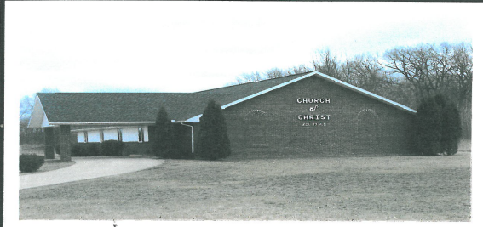
(B) = Birthday
(A) = Anniversary
Sunday | Monday | Tuesday | Wednesday | Thursday | Friday | Saturday
 |  |  |  | 1 | 2 | 3  (B) Betty Phillips
4  Bible Study  10:15 a.m. – 10:50 a.m.  Worship 11 a.m. – 12 p.m. | 5  (B) Anthony Rickle | 6 | 7  Bible Study  6:30 p.m. – 7:30 p.m. | 8 | 9 | 10
11  Bible Study  10:15 a.m. – 10:50 a.m.  Worship 11 a.m. – 12 p.m.  *Potluck  *Quilting 3:00 p.m. - 5:00 p.m. | 12 | 13 | 14  Bible Study  6:30 p.m. – 7:30 p.m.  (B) Barbara Eakins | 15  (B) Paula Hesselsweet | 16  (B) Allysen Esser | 17  *Clothes Closet & Food Pantry 10:00 a.m. – 12:00 p.m.
18  Bible Study  10:15 a.m. – 10:50 a.m.  Worship 11 a.m. – 12 p.m.  * Business Meeting | 19  (A) Steve & Jody Poe | 20 | 21  Bible Study  6:30 p.m. – 7:30 p.m. | 22 | 23 | 24
25  Bible Study  10:15 a.m. – 10:50 a.m.  Worship 11 a.m. – 12 p.m.  Quilting 3:00 p.m. - 5:00 p.m  (B) Cheryl Whitaker | 26  (B) Cheryl Whitaker  (B) Ellaree Elliott | 27 | 28  Bible Study  6:30 p.m. – 7:30 p.m.  (B) Doshie Everidge | 29 | 30 | 31
March 2018

